

**TRAINING REPORT**

**OF**

**SUMMER TRAINING, UNDERTAKEN**

**AT**

**“PG-TECHNOLOGY PRIVATE LIMITED”**

**ON**

**“WEB DESIGNING”**

**SUBMITTED IN PARTIAL FULFILLMENT OF THE DEGREE**

**OF**

**BECHLOR OF TECHNOLOGY**

**IN**

**Computer science and engineering**

**Submitted by:**

**Name: Anamika Kailey**

**Roll no.: 12101006**

**DEPARTMENT OF COMPUTER SCIENCE & ENGINEERING**

**PUNJABI UNIVERSITY**

**PATIALA-147002**

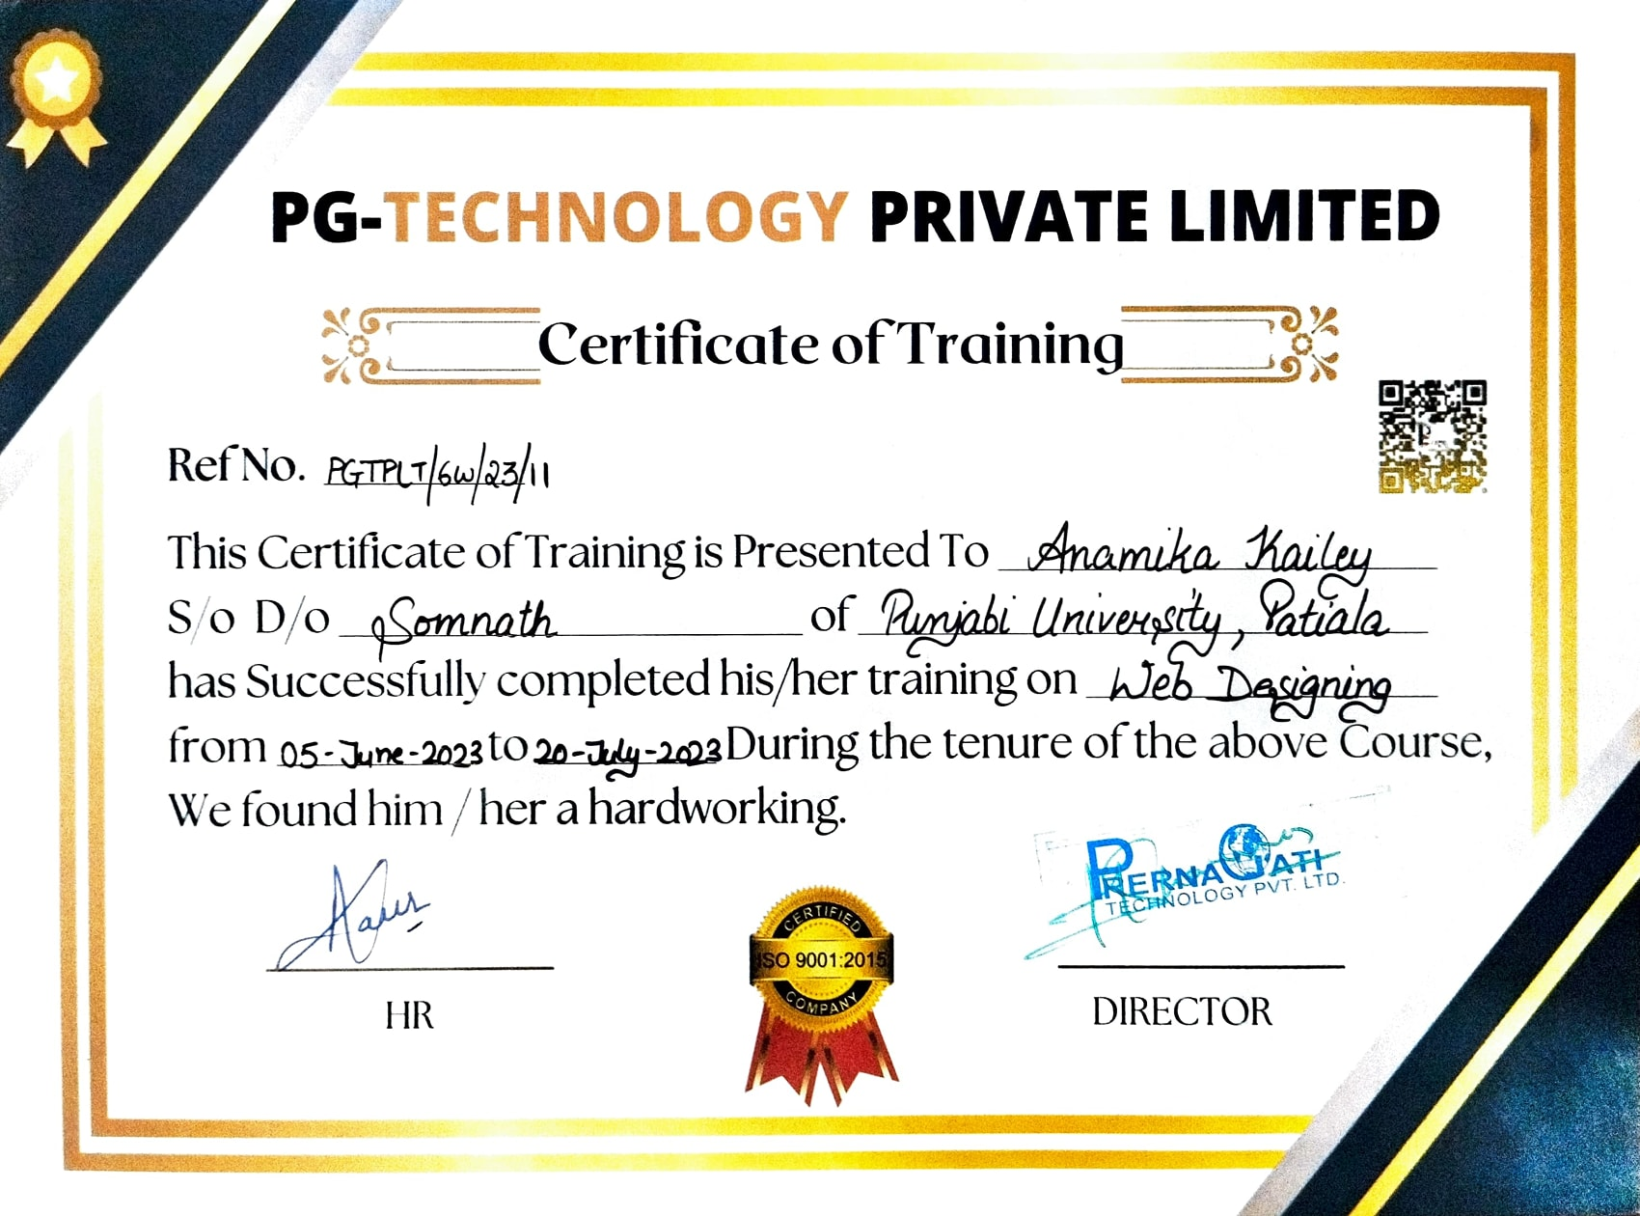

**DEPARTMENT OF COMPUTER SCIENCE & ENGINEERING PUNJABI UNIVERSITY, PATIALA**

**CANDIDATE'S DECLARATION**

I ANAMIKA KAILEY hereby declare that I have undertaken summer training at “PG-Technology Private Limited” during a period from June 5, 2023 to July 2, 2023 in partial fulfillment of requirements for the award of degree of B.Tech (Department of Computer Science & Engineering) at Punjabi University, Patiala. The work which is being presented in the training report submitted to Department of Computer Science & Engineering) at Punjabi University, Patiala is an authentic record of training work

Signature of the Student

The summer training Viva–Voce Examination of web designing has been

held on 29-september-2023 and accepted.

Signature of Examine

# ABSTRACT

This project involves the design and development of a dynamic and user-friendly website for a restaurant. The website aims to enhance the restaurant's online presence, provide customers with essential information, and facilitate seamless interaction. Key features of the website include an intuitive navigation system, an appealing menu presentation, online reservation capabilities, and an insight into the restaurant's story and ambiance.

Key Features: -

* Interactive user experience
* Menu showcase
* Reservation system
* Online ordering
* About us
* Contact us

# ACKNOWLEDGEMENT

I express my sincere gratitude to **DR. HIMANSHU AGGARWAL** worthy HOD for providing

me an opportunity to undergo summer training at **PG-Technology Private Limited**.

I am thankful to our project guide **MR. ARPIT SAXENA** for his support, cooperation, and

motivation provided to me during the training for constant inspiration, presence and blessings.

Lastly, I would like to thank the almighty and my parents for their moral support and our friends

with whom I shared my day-to-day experience and received lots of suggestions about quality of work.

ANAMIKA KAILEY

**ABOUT THE COMPANY/NSTITUTE**



PG Tech Pvt. Ltd. is a professional company for providing Web education and advanced 6 months & weeks industrial Training company in Chandigarh.

They provide training in various fields like front end developer and backend developer courses, mechanical and civil software training courses and basic computer courses along with job placement in Chandigarh & Mohali.

Here you will get fully updated labs where you can practice and enhance your capability. Your tutor will present full time so that if you are stuck then you could ask them for help and go ahead.

Their practically oriented mode of teaching method guarantees relevant direct hands-on experience towards solving problems and getting solutions under strict supervision by a trainer who guides them stepwise.

**CONTENTS**

**TOPICSPage No.**

**Certificate by Company/Industry/Institute i**

**Candidate’s Declaration ii**

**Abstract iii**

**Acknowledgement vi**

**About the Company/ Industry / Institute v**

**List of Figures vi**

**1 INTRODUCTION 1**

* 1. Project details…………………………………………………………………………….01
  2. About THE PARADISE (Restaurant & Bar)…………………………………………….01
  3. Introduction to Web Designing…………………………………………………………..01
  4. Technology used…………………………………………………………………………02
     1. HTML………………………………………………………………………….02
     2. CSS…………………………………………………………………………….04
     3. JAVA SCRIPT………………………………………………………………...07

1.5 Software used……………………………………………………………………………09

**2 TRAINING WORK UNDERTAKEN 11**

2.1 Sequential Learning Steps……………………………………………………………..11

2.2 Methodology to create the website…………………………………………………….12

2.4 How Restaurant Website works…………………….…………………………………15

**3 RESULTS AND DISCUSSION 17**

3.1 Snapshots ………………………………………………………………………….......17

**4 CONCLUSION AND FUTURE SCOPE 24**

4.1 Conclusion……………………………………………………………………………...24

4.2 Future Scope……………………………………………………………………………26

**REFRENCES** **28**

**LIST OF FIGURES**

**FIGURE NO.Page No.**

**1 INTRODUCTION 1**

1.1 Key Concept of web designing……………………..………………………………….2

**3 RESULTS AND DISCUSSION 17**

3.1 Homepage- Navigation bar view…………………..…………………………………..17

3.2 Homepage-offer & menu………..…………………..…………………………………18

3.3 Homepage Footer-……………………………….…………………………………….18

3.4 Menu-page……………………………………....…….……………………………….19

3.5 Order-Page………………………………………..……………………………………19

3.6 Order-page receipt…………….……………………….………………………………20

3.7 About page……………….……………………………………………………………20

3.8 About-page chefs………………………………………………….…………………..21

3.9 About-page review…………………………………………………………………….21

3.10 Contact-page…………………………………………………………………………22

3.11 Footer………………………………………………………………………………...22

**CHAPTER-1**

**INTRODUCTION**

**1.1 PROJECT DETAILS:**

* Title: - The Paradise (Reastaurant & Bar)
* Platform: - Web Designing
* Languages used: - HTML, CSS, JAVA SCRIPT

**1.2 ABOUT THE PARADISE (RESTAURANT & BAR):**

This project involves the design and development of a dynamic and user-friendly website for a restaurant. The website aims to enhance the restaurant's online presence, provide customers with essential information, and facilitate seamless interaction. Key features of the website include an intuitive navigation system, an appealing menu presentation, online reservation capabilities, and an insight into the restaurant's story and ambiance.

**1.3 INTRODUCTION TO WEB DESIGNING**

* **What is webpage?**

These are individual documents within a website that contain text, images, videos, links, and other multimedia elements. Web pages are organized to create a cohesive structure.

* **What is website?**

A website is a collection of related web pages, multimedia content, and other digital resources that are hosted on a web server and can be accessed and viewed through a web browser. Websites are typically used to present information, communicate ideas, provide services, and engage with users on the internet.

* **What is Web Design?**

Web design is the planning and creation of websites. Web designing is the process of planning, conceptualizing, and implementing the plan for designing a website in a way that is functional and offers a good user experience. User experience is central to the web designing process. Web designing essentially involves working on every attribute of the website that people interact with, so that the website is simple and efficient, allows users to quickly find the

1

information they need, and looks visually pleasing. All these factors, when combined, decide how well the website is designed.

Three layers of web design: -

1. HTML (Hyper Text Markup Language)

2. CSS (Cascading Style Sheet)

3.JS (Java Script)

JavaScript

Cascading Style Sheet (CSS)

Hypertext Markup Language (HTML)

Web Designing

User Interface

*Figure 1.1 Key Components of Web Designing*

**1.4 TECHNOLOGY USED**

**1.4.1 HTML**

HTML stands for Hyper Text Markup Language.

HTML is the standard markup language for creating Web pages. HTML describes the structure of a Web page. HTML consists of a series of elements. HTML elements tell the browser how to display the content.

HTML uses tags, elements, images, and some latest components to make Web Pages more attractive and user-friendly.

HTML works in conjunction with other technologies like CSS (Cascading Style Sheets) and

2

JavaScript to create interactive and visually appealing websites.

The HTML element is everything from the start tag to the end tag:

<tagname>Content goes here...</tagname>

|  |
| --- |
| *<html>*  *<head>*  *<title> webpage title</title>*  *</head>*  *<body>*  *Webpage content*  *</body>*  *</html>* |

The above code is a basic example that helps make up every web page.

<html>: The root element that contains all other elements.

<head>: Contains metadata and links to external resources like stylesheets and scripts.

<title>: contains the webpage title, displayed in the browser's title bar or tab.

<body>: Contains the visible content of the webpage that users interact with.

**Basic HTML Elements:**

* **Tags:**

HTML documents consist of elements, each represented by a pair of opening and closing tags. The opening tag contains the name of the element, and the closing tag is the same but preceded by a slash ("/"). Elements can also be self-closing if they don't require any content between the tags.

<h1> to <h6>: Headings of different levels.

<p>: Paragraph.

<a>: Anchor/link, used for creating hyperlinks.

<img>: Image.

<ul>: Unordered list.

<ol>: Ordered list.

<li>: List item.

3

<div>: Generic division or container for grouping content.

<span>: Inline container for styling or scripting.

* **Attribute:**

Tags can also include attributes, which provide additional information about an element or modify its behaviour. Attributes are placed within the opening tag and are usually in the form attribute="value".

For example: <img src="image.jpg" alt="An example image">

* **Comments:**

Comments in HTML are enclosed within <!-- and --> and are used to add notes or explanations that don't appear in the rendered output.

* **Forms and Input:**

HTML forms allow users to input data. Common form elements include text fields, radio buttons, checkboxes, and buttons.

**1.4.2 CSS**

Cascading Style Sheets (CSS) is a fundamental technology used in web development to control the visual presentation and layout of HTML (Hypertext Markup Language) documents. It enables developers to separate the structure and content of a web page from its design and appearance, allowing for greater flexibility and easier maintenance. CSS is responsible for controlling elements such as colors, fonts, spacing, positioning, and other stylistic aspects of web content.

CSS Syntax:

***Property 1: Value;***

***Property 2: Value;***

The COLON separates the two entities.

The SEMICOLON closes the declaration.

CSS comprises style rules that are interpreted by the browser and then applied to the corresponding elements in your document. A style rule set consists of a selector and declaration block.

4

**Selector:**A selector in CSS is used to target and select specific HTML elements to apply styles to.

**Declaration:** A declaration in CSS is a combination of a property and its corresponding value.

*Selector -- h1  
Declaration -- {*

*color: blue;*

*font size:12px;*

*}*

The selector points to the HTML element you want to style.

The declaration block contains one or more declarations separated by semicolons.

Each declaration includes a CSS property name and a value, separated by a colon.

*Example:- p {*

*color: blue;*

*text-align: center;*

*}*

**How CSS is different from HTML?**

HTML is used to define a web page structure, while CSS is used to style it. CSS can be internal or external depending on the requirement, and has higher backup and support than HTML.

**CSS Inline:**

* Before CSS this was the only way to apply styles
* Not an efficient way to write as it has a lot of redundancy
  + But the idea of separation of concerns still lost
* Self-contained
* Uniquely applied on each element

*Example:*

*<h3 style=” color:red”> Have a great day </h3>*

*<p style =” color: green”> I did this , I did that </p>*

5

**Internal CSS:**

* With the help of style tag, we can apply styles within the HTML file
* Redundancy is removed
* But the idea of separation of concerns still lost
* Uniquely applied on a single document

*Example:-*

*< style>*

*h1{*

*color:red;*

*}*

*</style>*

**External CSS:**

* With the help of <link> tag in the head tag, we can apply styles
* Reference is added
* File saved with .css extension
* Redundancy is removed
* The idea of separation of concerns is maintained
* Uniquely applied to each document

*Example:*

*<head>*

*<link rel="stylesheet" type="text/css" href="name of the Css file">*

*</head>*

*h1{*

*color:red; //.css file*

*}*

6

**1.4.3 JAVA SCRIPT**

JavaScript is a high-level, interpreted programming language primarily used for adding interactivity and dynamic behaviour to websites. It's one of the core technologies of web development, along with HTML (Hypertext Markup Language) and CSS (Cascading Style Sheets). JavaScript allows developers to create interactive elements, handle user input, manipulate the Document Object Model (DOM), and communicate with servers, among other things.

* JavaScript is the world's most popular programming language.
* JavaScript is the programming language of the Web.
* JavaScript is easy to learn.

**Key features and concepts of JavaScript include:**

* Client-Side Scripting
* Event Handling
* DOM Manipulation
* Variables and Data Types
* Functions
* conditional statements
* loops
* Object-Oriented Programming (OOP)

**Syntax and Basic Concepts:**

JavaScript code is written in plain text and is typically embedded within HTML files using <*script>* tags.

Statements are the basic building blocks of JavaScript code. They are terminated by semicolons (;), though they can often be omitted due to automatic semicolon insertion.

Comments can be added using // for single-line comments or /* */ for multi-line comments.

**Variables and Data Types:**

Variables are used to store and manage data. They are declared using the var, let, or const keywords.

7

JavaScript has several built-in data types, including strings, numbers (both integers and floats), booleans, arrays, objects, functions, and symbols (ES6).

**Operators:**

JavaScript supports various operators for performing arithmetic, comparison, logical, and assignment operations.

String concatenation is done using the + operator.

**Control Flow:**

Conditional statements like if, else if, and else are used to execute different code blocks based on specific conditions.

Switch statements allow for selecting different code blocks based on the value of an expression.

Loops:

for, while, and do...while loops are used to execute a block of code repeatedly as long as a specific condition is met.

**Functions:**

Functions in JavaScript are blocks of reusable code that can take parameters and return values.

Functions can be declared using the function keyword or defined as arrow functions (ES6).

They can be stored in variables, passed as arguments to other functions, and returned as values from functions.

**DOM Manipulation:**

The DOM is a representation of the webpage's structure, and JavaScript allows developers to interact with and manipulate it.

DOM manipulation enables dynamic updates to a webpage's content and structure, creating interactive user interfaces.

**Events and Event Handling:**

8

JavaScript can be used to handle various events like clicks, keyboard inputs, mouse movements, and more.

Event handlers are functions that are triggered when specific events occur.

**Libraries and Frameworks:**

JavaScript has a rich ecosystem of libraries and frameworks that provide pre-built solutions for common tasks.

Libraries like jQuery simplify DOM manipulation and AJAX requests, while frameworks like React, Angular, and Vue.js offer powerful tools for building complex web applications.

* 1. **SOFTWARE USED**

There are various software and tools that can be used to build **RESTAURANT WEBSITE**. Here are some of the commonly used ones:

* **Text Editors / Integrated Development Environments (IDEs):** Software tools like Visual Studio Code, Sublime Text, Atom, and JetBrains WebStorm are commonly used by developers to write and edit code efficiently.
* **Front-End Frameworks and Libraries:** Frameworks like React.js, Angular, Vue.js, and libraries like jQuery, Bootstrap, and Material-UI are used to streamline front-end development, create reusable components, and enhance user interfaces.
* **Version Control Systems:** Tools like Git, SVN (Subversion), and Mercurial are used to manage changes to the codebase, track versions, and facilitate collaboration among team members.
* **Browser Developer Tools:** Developer tools available in web browsers, such as Chrome DevTools, Firefox Developer Tools, and Safari Web Inspector, help debug, profile, and optimize front-end code and performance.
* **Development tools:** Code editors like Visual Studio Code or Atom, version control systems like Git, and project management tools like Trello or Asana can be used to manage the development process.

9

* **Responsive Design Tools:** Tools like Adobe XD, Sketch, and Figma aid in designing responsive layouts and prototypes for web apps.

10

**CHAPTER- 2**

**TRAINING WORK UNDERTAKEN**

**2.1 SEQUENTIAL LEARNING STEPS**

Web designing involves creating the visual and interactive elements of a website. Here are the sequential steps you can follow for web designing using HTML, CSS, and JavaScript:

* **Planning and Research:**
* Define the purpose of the website and the target audience.
* Research similar websites for inspiration and to understand design trends.
* Create a sitemap to outline the structure and navigation of the website.
* **Wireframing and Mockups:**
* Sketch a basic layout of the website using pen and paper or digital tools.
* Create a more detailed wireframe using software like Adobe XD, Sketch, or Figma.
* Design mockups for different screen sizes (desktop, tablet, mobile).
* **HTML Structure:**
* Begin by creating the basic HTML structure using tags like <html>, <head>, and <body>.
* Divide the content into sections using semantic HTML elements like <header>, <nav>, <main>, <section>, <article>, <footer>, etc.
* **CSS Styling:**
* Link an external CSS stylesheet to your HTML document using the <link> tag.
* Apply styles to HTML elements using CSS properties like color, font-family, margin, padding, etc.
* Use classes and IDs to target specific elements for styling.

11

* **Layout and Positioning:**
* Implement responsive design using CSS media queries to adapt the layout for different screen sizes.
* Utilize CSS Flexbox or CSS Grid for creating layouts and positioning elements.
* **Interactive Elements with JavaScript:**
* Integrate JavaScript for interactivity and dynamic behavior.
* Add event listeners to elements, like buttons and forms, to trigger actions.
* Use JavaScript to create animations, sliders, and other interactive features.
* **Responsive Web Design:**
* Deepen your understanding of responsive design principles, including fluid grids, flexible media, and breakpoints.
* Implement media queries and CSS techniques to create websites that work well on various devices.
* **Introduction to Frameworks and Libraries:**
* Familiarize yourself with popular front-end libraries and frameworks like React, Vue.js, or Angular for building more complex web applications.

**2.2 ABOUT RESTAURANT WEBSITE**

Developing a restaurant website involves several steps and methodologies to ensure a successful project. Here's a methodology to guide you through the process:

1. Define Project Scope and Objectives:

- Clearly define the goals and objectives of the restaurant website project. Determine what you want to achieve with the website, such as online ordering, reservations, menu display, and customer engagement.

2. Gather Requirements:

- Identify and gather requirements from stakeholders, including restaurant owners, managers,

12

staff, and potential website users (customers).

- Create a detailed requirements document that outlines functionality, design preferences, and any specific features needed.

3. Planning and Project Setup:

- Develop a project plan that includes timelines, milestones, and resource allocation.

- Set up a project team, including web designers, developers, content creators, and testers.

- Define the technology stack, including web development frameworks, content management systems (CMS), and hosting solutions.

4. Design Phase:

- Create wireframes or prototypes to visualize the website's layout and structure.

- Design the user interface (UI) and user experience (UX) to ensure an intuitive and visually appealing website.

- Consider responsive design to ensure the website works well on various devices and screen sizes.

5. Development:

- Build the website based on the approved designs and requirements.

- Develop features such as menu display, online ordering, reservation system, user registration, and content management.

- Implement security measures to protect user data and payment information.

- Conduct regular testing to identify and fix bugs or issues.

6. Content Creation:

- Create high-quality content for the website, including menu descriptions, images, and promotional materials.

- Optimize content for search engines (SEO) to improve visibility in search results.

7. Testing:

- Perform thorough testing of the website's functionality, usability, and security.

- Test the website on various browsers and devices to ensure compatibility.

13

- Conduct user acceptance testing (UAT) with restaurant staff to validate that the system meets their needs.

8. Deployment:

- Choose a reliable hosting provider and deploy the website to a production server.

- Configure domain and DNS settings to make the website accessible to users.

9. Training and Documentation:

- Provide training to restaurant staff on how to manage the website, update menus, process online orders, and handle reservations.

- Create documentation for future reference and troubleshooting.

10. Marketing and Promotion:

- Develop a marketing plan to promote the website to potential customers through various channels, including social media, email marketing, and local advertising.

- Consider implementing online marketing strategies like SEO, pay-per-click advertising, and social media advertising.

11. Maintenance and Support:

- Establish a maintenance plan to regularly update content, fix issues, and make improvements.

- Provide ongoing customer support to address user inquiries and problems.

- Monitor website performance and security.

12. Evaluation and Feedback:

- Collect feedback from users and restaurant staff to make continuous improvements.

- Use website analytics to track user behavior and measure the website's success against defined objectives.

13. Scaling and Expansion (Optional):

- Consider future enhancements and expansions, such as mobile apps, loyalty programs, or additional features based on user feedback and market trends.

14

14. Review and Iteration:

- Periodically review and iterate on the website to keep it up-to-date and aligned with changing business needs and industry standards.

By following this methodology, you can effectively plan, develop, and maintain a restaurant website that meets the needs of both the restaurant and its customers.

**2.3 How Restaurant Website Works?**

A restaurant project website typically works as an online platform that facilitates various aspects of restaurant operations and customer interactions. Here's a breakdown of how such a website typically functions:

1. Home Page:

- The home page is the starting point for users visiting the website.

- It often features high-quality images of the restaurant, a brief description, and essential navigation options.

2. Menu Display:

- The website usually includes a menu section where customers can view the restaurant's offerings, including food and beverages.

- Each menu item is typically accompanied by a description, price, and sometimes images.

3. Online Ordering:

- Many restaurant websites offer online ordering functionality, allowing customers to select items from the menu and place orders electronically.

- Customers can add items to their cart, specify quantities, customize orders (e.g., extra toppings or special instructions), and review their orders before finalizing.

4. Reservation System:

- Some restaurant websites feature a reservation system that enables customers to book tables for a specific date and time.

- Users can choose the number of guests and provide contact details to confirm the reservation.

15

5. Customer Feedback and Reviews:

- Some restaurant websites include a section where customers can leave reviews and ratings based on their dining experiences.

- Restaurant owners and managers may respond to reviews and use feedback to improve services.

6. Feedback and Improvement:

- Continuous monitoring of website analytics and customer feedback helps identify areas for improvement.

- The website is regularly updated to enhance user experience and meet changing customer preferences.

In summary, a restaurant project website serves as a digital platform for customers to explore the restaurant's offerings, place orders, make reservations, and provide feedback. It also streamlines restaurant management tasks and enhances the overall dining experience.

16

**CHAPTER – 3**

**RESULTS AND DISCUSSION**

**THE PARADISE**- This project involves the design and development of a dynamic and user-friendly website for a restaurant. The website aims to enhance the restaurant's online presence, provide customers with essential information, and facilitate seamless interaction. Key features of the website include an intuitive navigation system, an appealing menu presentation, online reservation capabilities, and an insight into the restaurant's story and ambiance.

**3.1 SNAPSHOTS OF WEBSITE**

**3.1.1 HOME PAGE:**

The home page contains –

* Navigation bar
* Advertisement
* Book table
* Footer

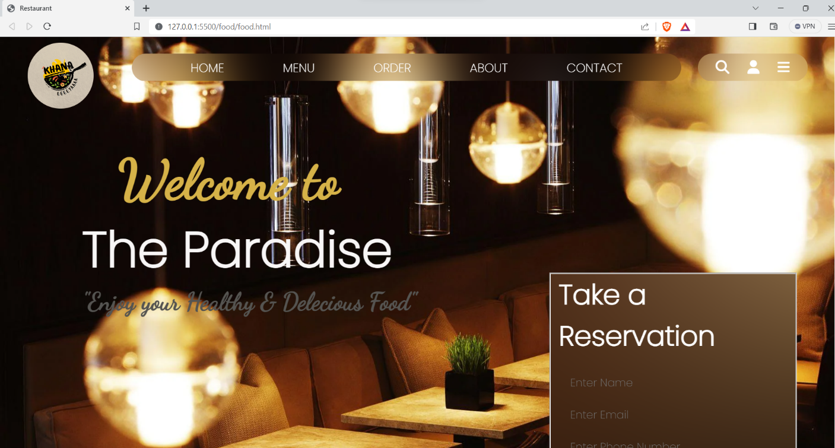

*Figure 3.1 Homepage – Navigation bar view*

17

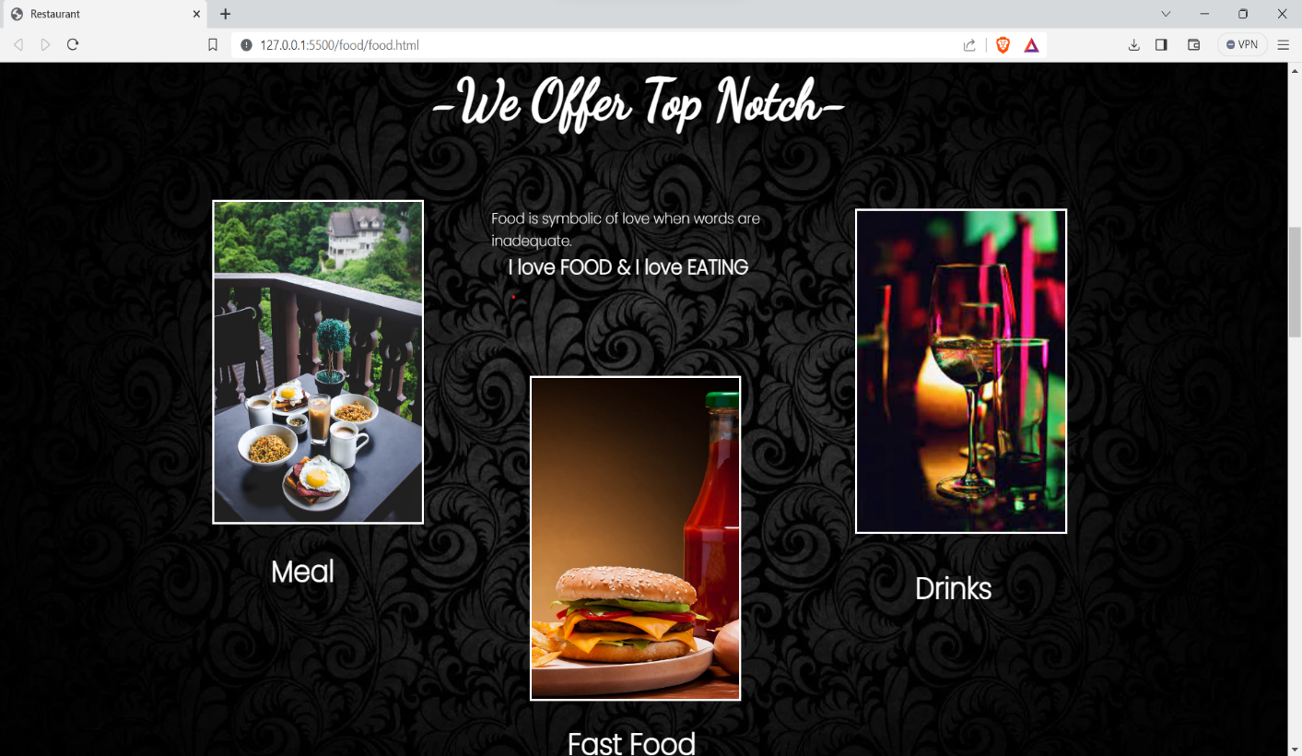

*Figure 3.2 Homepage – offer and menu*

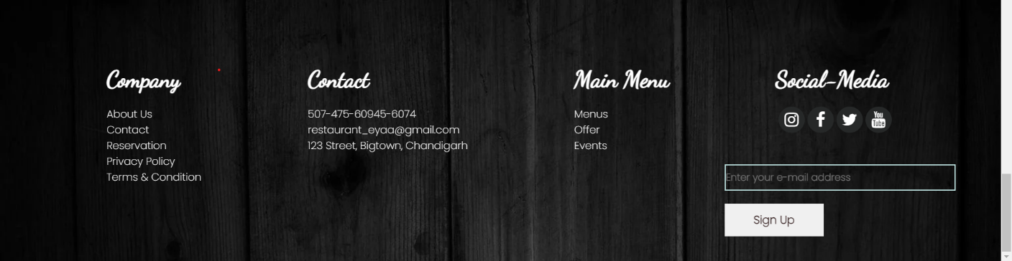

*Figure 3.3 Homepage – footer*

**3.1.2 MENU PAGE:**

You can view menu with the help of this page.

18

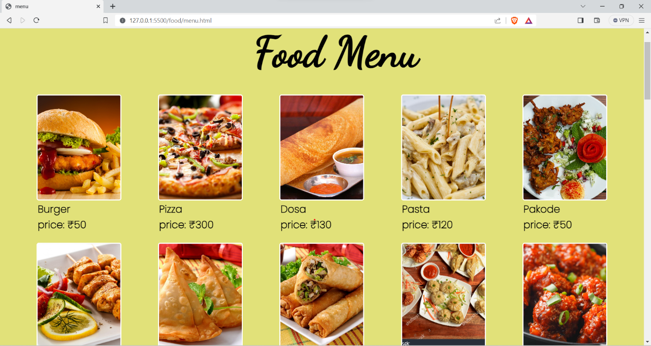



*Figure 3.4 Menu page- food menu*

**3.1.3 ORDER PAGE**

In this page you can order the food by giving details and a receipt of order is printing for customer.

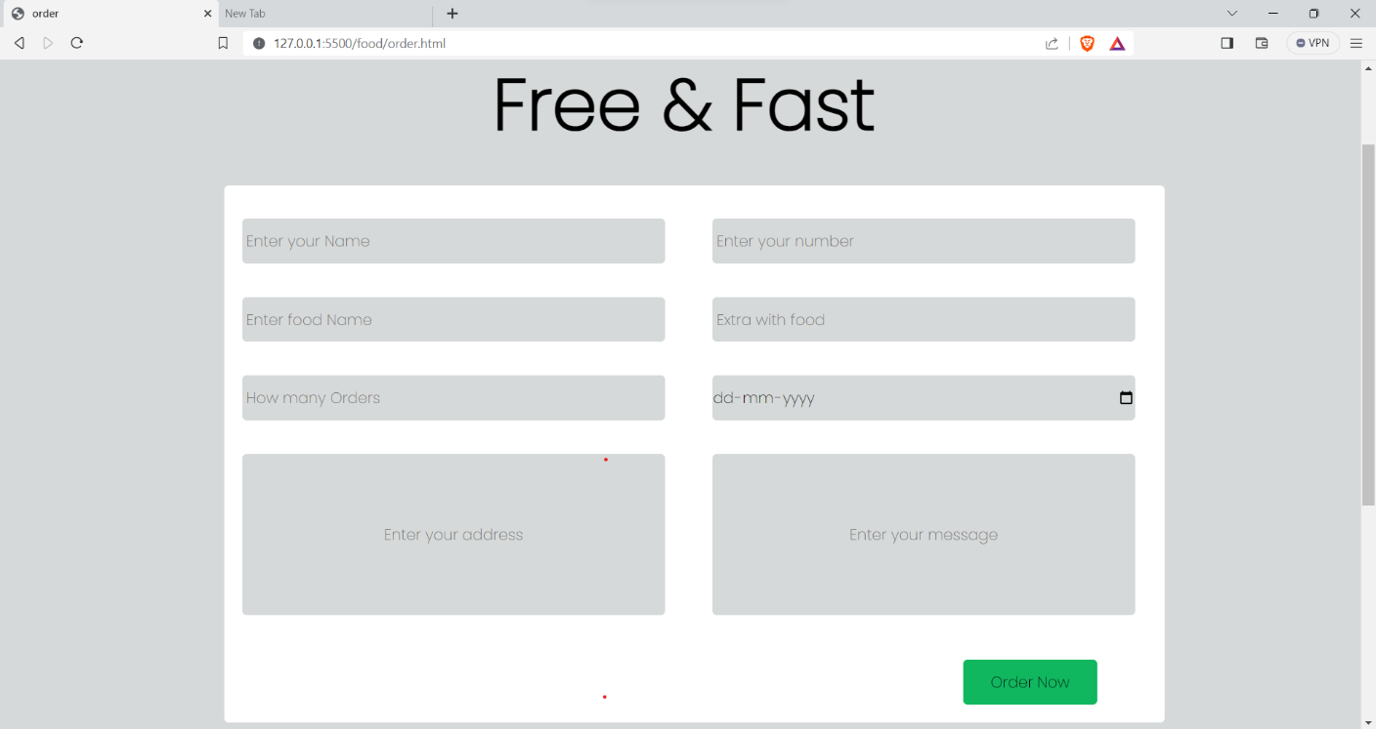

**Order button**

*Figure 3.5 order page*

19

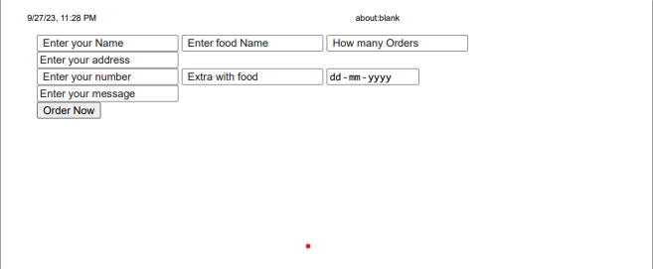

*Figure 3.6 order page- receipt*

**3.3.4 ABOUT PAGE**

About page contain the information about the restaurant like master chefs details, review of customers and services.

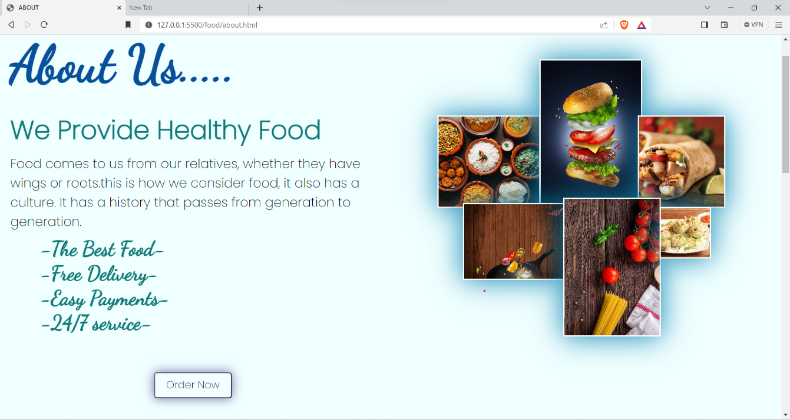

*Figure 3.7 about page*

20

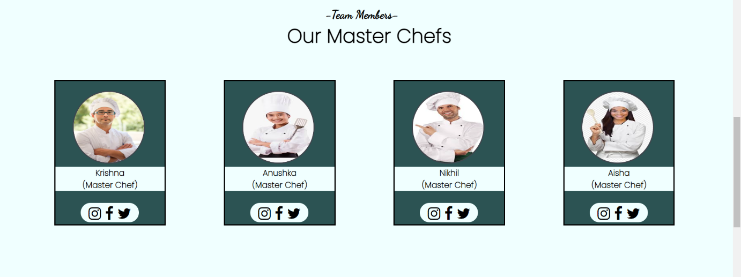

*Figure 3.8 about page-chefs*

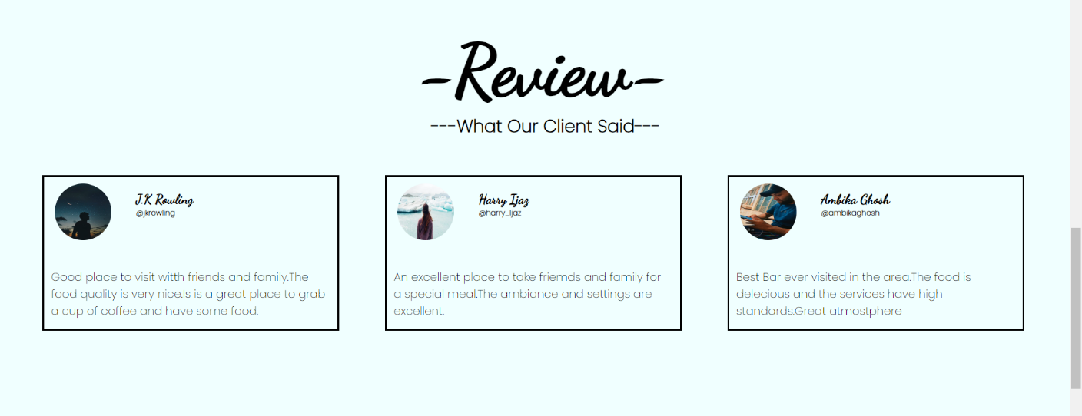

*Figure 3.9 about page-review*

**3.1.5 CONTACT PAGE**

This page contains

* Address
* Phone number
* Email

21

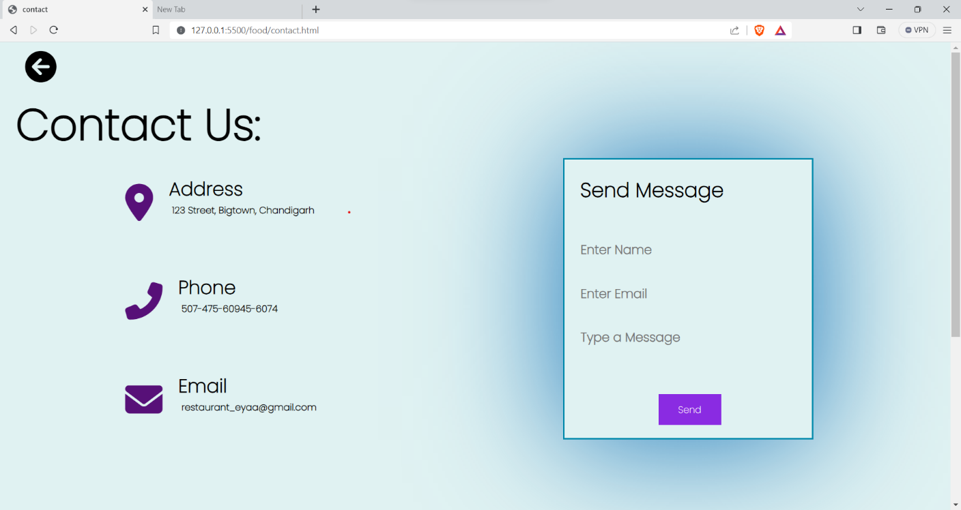

*Figure 3.10 Contact page*

**3.1.6 Footer**

**Social media information**



*Figure 3.11 footer*

The footer of a webpage is a vital section found at the bottom, summarizing essential website information and navigation links. It commonly includes contact details, such as address, phone number, and email, facilitating user communication. It may display social media icons to connect

22

with the website on various platforms. Often, there's a brief about the organization or website's mission and values. Additionally, legal information like terms of use, privacy policy, and copyright notices are typically present to ensure transparency and compliance. The footer offers seamless navigation, enhancing user experience and providing a comprehensive snapshot of the website.

23

**CHAPTER – 4**

**CONCLUSION AND FUTURE SCOPE**

**4.1 CONCLUSION :-**

In conclusion, the development and design of the restaurant website have been a comprehensive and creative project. Our objective was to create a visually appealing, user-friendly, and functional website that effectively represents the restaurant's brand and engages its target audience. Throughout the project, we have made significant strides in achieving these goals, and the results are promising.

Here are the key takeaways from our web designing project:

In summary, our web designing project has successfully delivered a restaurant website that reflects the restaurant's identity and offers an exceptional user experience. However, the journey doesn't end here. Continuous monitoring, feedback collection, and ongoing improvements are essential to ensure the website remains a dynamic and effective tool for the restaurant's online presence.

Overall, our web design project has laid a strong foundation for the restaurant's digital presence, and we are excited about the positive impact it will have on the restaurant's growth and success in the competitive culinary landscape.

**4.1.1. Design and Aesthetics:**

- Create a visually appealing and cohesive design that reflects the restaurant's brand identity, including logo, colour scheme, and typography.

- Ensure responsive design to optimize user experience on various devices and screen sizes.

**4.1.2. User Experience (UX):**

- Develop an intuitive and user-friendly interface to facilitate easy navigation.

- Implement a menu structure that organizes dishes, drinks, and other information logically.

- Ensure fast loading times and smooth interactions to enhance user satisfaction.

24

**4.1.3. Content Presentation:**

- Present the restaurant's menu items with detailed descriptions, high-quality images, and pricing information.

- Include a gallery section to showcase the restaurant's interior, ambiance, and food presentation.

**4.1.4. Functionality:**

- Integrate an online reservation system that allows users to book tables with ease.

- Implement an online ordering system for takeout or delivery, including secure payment processing.

- Incorporate a contact form for general inquiries and feedback.

**4.1.5. SEO and Online Visibility:**

- Optimize the website for search engines (SEO) to improve organic search rankings.

- Use relevant keywords and meta-data to increase visibility on search engine results pages.

**4.1.6. Mobile Responsiveness:**

- Ensure that the website functions seamlessly on mobile devices, such as smartphones and tablets.

**4.1.7. Analytics and Reporting:**

- Integrate analytics tools (e.g., Google Analytics) to track website performance, user behavior, and conversion rates.

- Provide regular reporting to monitor the website's effectiveness and make data-driven decisions.

**4.1.8. Security:**

- Implement security measures to protect user data and online transactions.

- Ensure compliance with data privacy regulations.

25

**4.1.9. Content Management System (CMS):**

- Include a user-friendly CMS that allows restaurant staff to update menu items, prices, and other content as needed.

**4.1.10. Social Media Integration:**

- Integrate links to the restaurant's social media profiles and enable easy sharing of website content on social platforms.

**4.2 FUTURE SCOPE:-**

1. Mobile Optimization: Ensure your website is fully responsive for mobile devices. As more users access websites via smartphones and tablets, optimizing the mobile experience is critical.

2. Online Ordering and Delivery: Expand your project to include robust online ordering capabilities. Consider integrating with delivery services or implementing your own delivery system to cater to the increasing demand for online food delivery.

3.User Accounts and Personalization: Develop user account features that enable customers to save preferences, order history, and payment details. Leverage this data to provide personalized recommendations and loyalty programs.

4. AI Integration: Incorporate AI-driven chatbots for customer support and automation. AI can also help analyze user data to refine your offerings and marketing strategies.

5. Sustainability and Transparency: Highlight your restaurant's sustainability efforts, emphasizing eco-friendly practices, locally sourced ingredients, and food traceability. This aligns with growing consumer interest in ethical dining choices.

6. SEO and Marketing: Invest in SEO to improve your website's visibility. Utilize online marketing channels, such as social media and email marketing, to reach a wider audience and engage with customers effectively.

7. Virtual Experiences: Explore virtual events, cooking classes, and immersive experiences to keep users engaged and generate additional revenue streams.

26

8. Blockchain for Trust: Consider implementing blockchain technology to enhance transparency in the supply chain, building trust with customers who seek information about food sourcing.

9. Accessibility: Ensure your website complies with accessibility standards to make it inclusive and accessible to all users, including those with disabilities.

Adapting and expanding your project along these lines can help your restaurant website thrive in a competitive and ever-evolving digital landscape.

27

**REFERENCES**

* **Websites:**

1. w3school - <https://www.w3schools.com/>
2. TripAdvisor – <https://www.tripadvisor.com/>
3. JavaScript.info **-** https://javascript.info/

Importance: JavaScript.info is a comprehensive guide to JavaScript. It covers the language basics, DOM manipulation, and advanced concepts.

* **Online Sources:**

Websites like Udemy, Coursera, and freeCodeCamp offer courses on web development, including HTML, CSS, and JavaScript.

Importance: These platforms provide structured learning and can support your understanding of the technologies used in the project.

* **Magazine and News Articles**

Articles from reputable travel and technology magazines or news outlets.

28